EGOERA

ZIRKULAZIOA HIZTEGIA  2016 | ZIRKULAZIOA HIZTEGIA  2018
342  hormigoi-makina (4)  Sin. betoi-makina (4)  Hormigoiaren osagai diren elementuak garraiatzeko bereziki egindako ibilgailua; osagai horiek garraiatzen dituen artean nahas ditzake.  es hormigonera  fr bétonnière  en concrete mixer | 354  hormigoi-makina (4)  Sin. betoi-makina (4)  Hormigoiaren osagai diren elementuak garraiatzeko bereziki egindako ibilgailua; osagai horiek garraiatzen dituen artean nahas ditzake.  es hormigonera  fr bétonnière  en concrete mixer
343  hormigoitzeko ponpa (4)  Hormigoi fluidifikatua mugitzeko presio-ponpa bat duen ibilgailua.  es bomba de hormigonar | 355  hormigoitzeko ponpa (4)  Hormigoi fluidifikatua mugitzeko presio-ponpa bat duen ibilgailua.  es bomba de hormigonar

PROPOSAMENA
354
hormigoi-kamioi (4)
Sin. betoi-kamioi (4)

Hormigoiaren osagai diren elementuak garraiatzeko bereziki egindako kamioia, garraiatu bitartean osagai horiek nahas ditzakeena.

es camión hormigonera
fr camion malaxeur; camion toupie; camion-bétonnière
en concrete mixer truck

355
hormigoi-ponpadun kamioi (4); betoi-ponpadun kamioi (4)

Hormigoi fluidifikatua isurtzeko presio-ponpa bat duen kamioia.
es camión bomba de hormigón
fr camion pompe à béton
en concrete pump truck

AZTERKETA

REGLAMENTO GENERAL DE VEHÍCULOS
Real Decreto 2822/1998, de 23 de diciembre, por el que se aprueba el Reglamento General de Vehículos

56 Hormigonera
Vehículo especialmente construido para el transporte de los elementos constitutivos del hormigón, pudiendo efectuar su mezcla durante el transporte.

66 Bomba de hormigonar
Vehículo autobomba especialmente diseñado para movimiento de hormigón fluido.

46 Bomberos
Vehículo destinado al Servicio de los Cuerpos de Bomberos.
61 Autobomba
Vehículo equipado con una autobomba de presión para movimiento de materiales fluidificados.

1-HORMIGONERA

VIALTEST
https://vialtest.com/manual-del-conductor/permiso-C/definiciones/11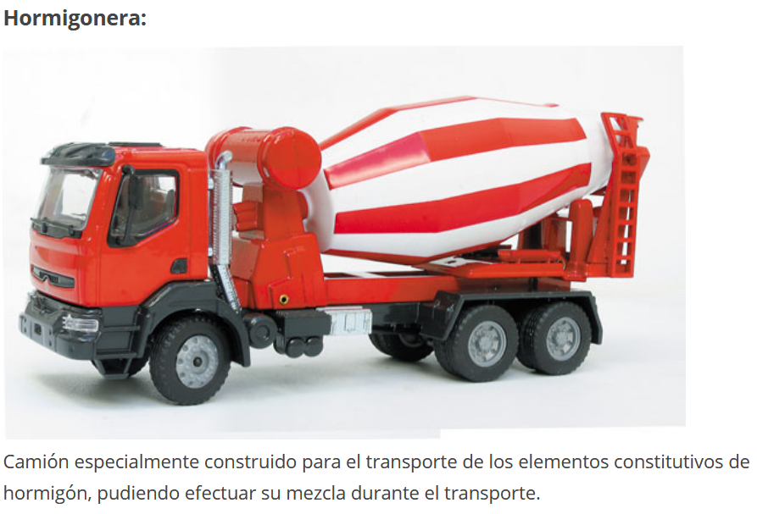

DICCIONARIO DE LOGÍSTICA
Diccionario de logística / David Soler-- 2ª ed-- Barcelona : Marge Books, 2009, 373 p. : il. ; 21 cm -- (Biblioteca de logística) ISBN 978-84-92442-24-9

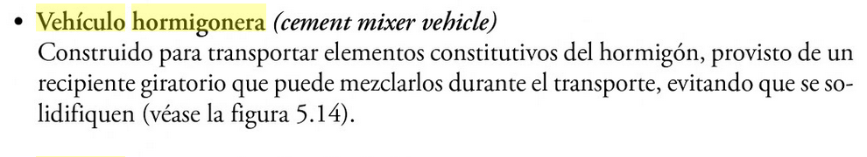
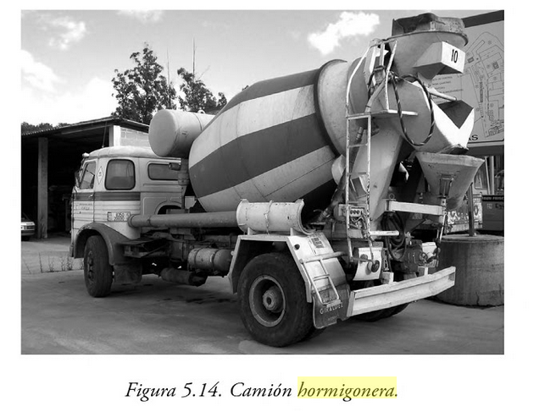

DICCIONARIO DE LA CONSTRUCCIÓN
http://www.diccionariodelaconstruccion.com/procesos-productivos-obra-civil/plantas-de-hormigon-y-de-aridos/autohormigonera

AUTOHORMIGONERA
Es un camión que lleva montada una cuba giratoria, por lo general de eje inclinado, y que se utiliza para transportar el hormigón fabricado en una central de hormigonado a largas distancias, a la vez que se mantiene el amasado de la mezcla, que en el caso de centrales dosificadoras se reserva a la autohormigonera. Su capacidad es de varios metros cúbicos, siendo utilizadas las más pequeñas en aquellos puntos donde el acceso o la dificultad de maniobra las hace aconsejables. Descargan mediante canaletas directamente o a bombas de hormigón para su puesta en obra.

AUTOMATIC CONCRETE MIXER
This is normally an inclined axle lorry that is fitted with a rotating tank that is used for transporting the concrete manufactured at a concrete plant over long distances, which at the same time keeps mixing the combination which is reserved for the automatic concrete mixer in the case of dosage plants. It has a capacity of various squared metres, and it is advisable to use only the smallest ones in points where access or manoeuvrability is difficult. They can be devised to work as permanent or transitory installations for their use on various sites.

CAMION TOUPIE
Camion sur lequel est montée une bétonnière rotative, dont l'axe est généralement incliné, et que l'on utilise pour transporter le béton fabriqué dans une centrale à béton sur de longues distances tout en continuant à malaxer le mélange. D'ailleurs, dans

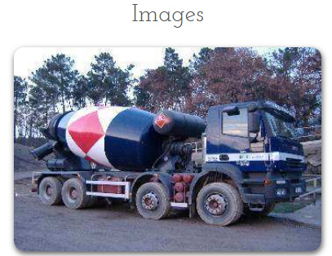

CERCATERM
TERMCAT, CENTRE DE TERMINOLOGIA. Diccionari de trànsit. Barcelona: Enciclopèdia Catalana: TERMCAT, Centre de Terminologia, 2000. 245 p. (Diccionaris de l'Enciclopèdia. Diccionaris terminològics)
ISBN 84-412-0477-2; 84-393-5162-3
Les dades originals poden haver estat actualitzades o completades posteriorment pel TERMCAT.
- ca camió formigonera, n m
- ca formigonera, n f sin. compl.
- es camión hormigonera
- fr camion-bétonnière
- en concrete mixer truck
<Trànsit > Vehicle > Tipologia>
Camió que porta muntada sobre el bastidor una cisterna rotativa, apta per a transportar formigó en estat pastós.

TERMIUM

FITXA: 2012-06-21
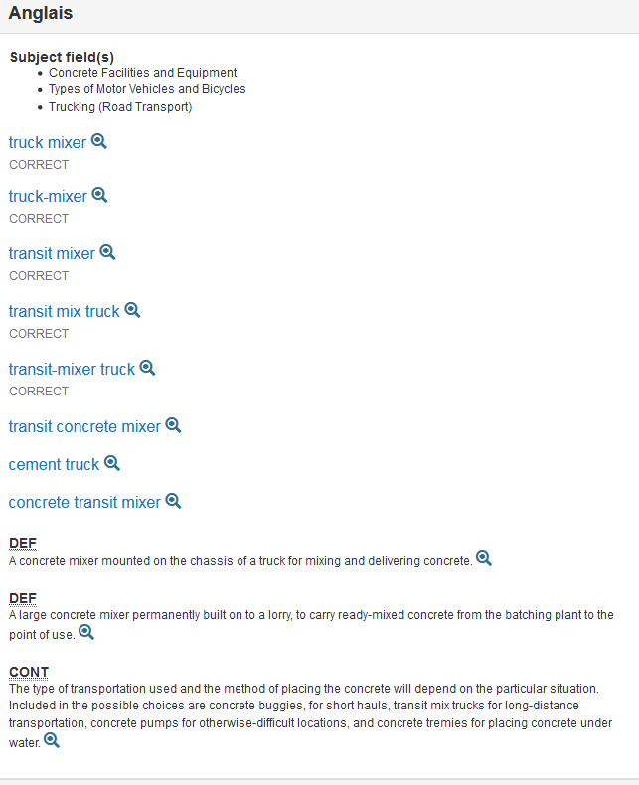

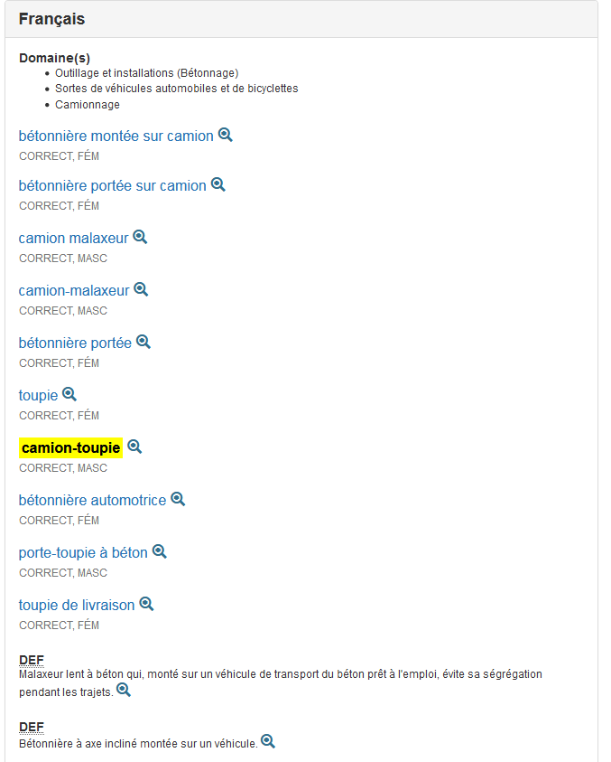

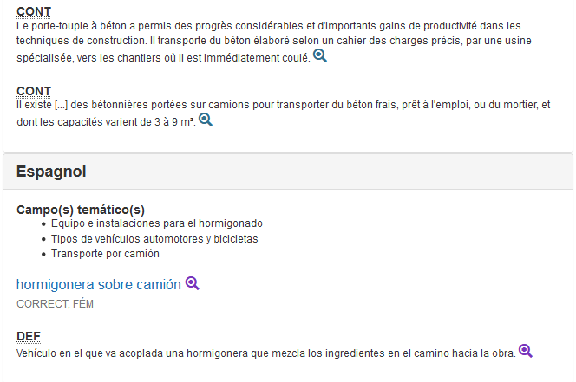

WIKIPÉDIA
Malaxeur (camion)
Un camion malaxeur ou bétonnière portée, appelé communément camion toupie, désigne un camion spécialisé dans le transport du béton frais. Le camion est pour l'essentiel pourvu d'un réservoir rotatif en forme de toupie et incliné suivant un axe presque horizontal.

WIKIPEDIA_EUSKARAZ

Kamioi
(…)
Kamioia motordun ibilgailua da, salgai edo karga astunak errepidez garraiatzeko ibilgailu handi eta sendoa hain zuzen ere^{[1]}. Autoa baino handiagoa da eta haren helburua, pertsonak eramatea baino, ondasunak garraiatzea da.
Erabileraren arabera, honako kamioi mota nagusiak daude:
- Hormigoi kamioia
- Suhiltzaileen kamioia
- Zisternadun kamioia
- Zarama jasotzen duen kamioia
- Erremolke bezala erabiltzen den kamioia
- Obretan erabiltzen den kamioia, hondakinak azkar jasotzeko eta atzeko partea inklinatuz guztiz husten dena (dumper)
- Trailerra
- Termikoki isolaturiko kamioiak

EUSKALTERM
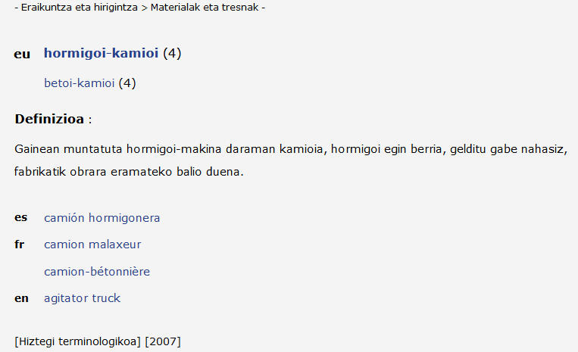

2-BOMBA DE HORMIGÓN

MAQUINARIA MÓVIL. GENCAT.

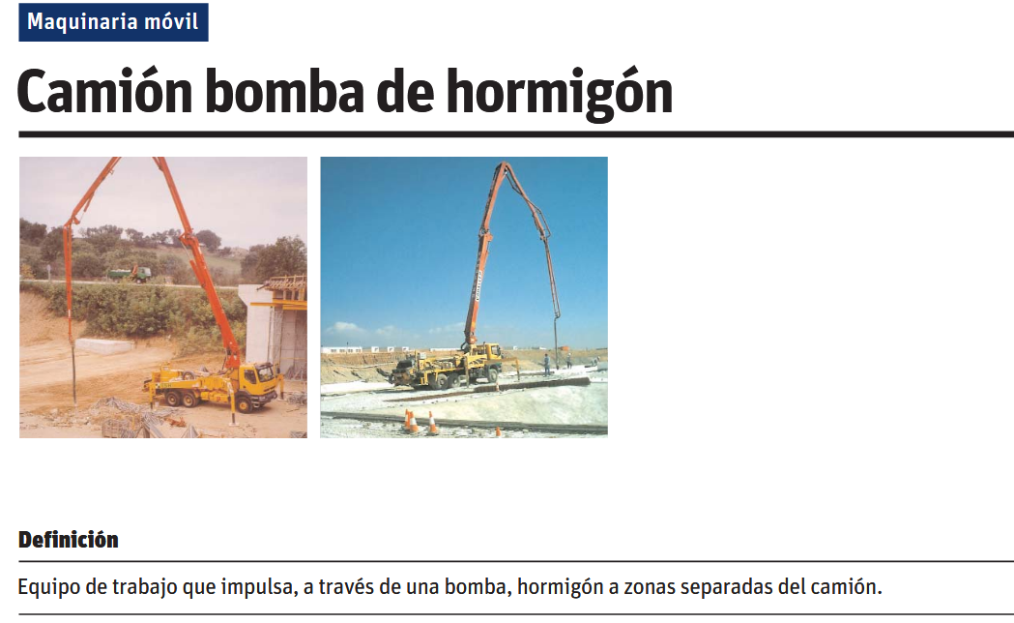

DICCIONARIO DE LA CONSTRUCCIÓN
http://www.diccionariodelaconstruccion.com/buscar/?q=basculante

BOMBA DE HORMIGONADO
Máquina que permite transportar el hormigón por medio de conductos y tubos, desde el lugar donde se prepara el hormigón, o donde puede situarse el camión de transporte, hasta el lugar donde se ha de colocar. Este sistema de transporte por impulsión ofrece varias ventajas: - Rapidez, buen rendimiento y reducción de mano de obra. - Grandes distancias y alturas de transporte, máxima de 500 m en horizontal y 100 m de altura.

CONCRETING PUMP
Machine employing conduits and tubes to transport concrete from the place of mixing, or from wherever the transportation lorry may be, to the site where it is to be used. This propulsion-based transportation system has several advantages: - Speed, good productivity and reduced labour requirements. - Can cover great distances and heights; maximum of 500 m horizontally, and 100 m in altitude.

POMPE À BÉTON
Machine qui permet de transporter le béton par l'intermédiaire de conduits et de tubes, depuis le lieu où est préparé le béton, ou bien depuis le lieu où peut stationner le camion de transport, jusqu'au lieu où il doit être coulé. Ce système de transport

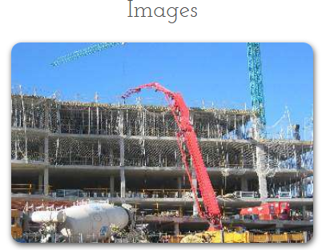

CERCATERM

UNIVERSITAT POLITÈCNICA DE CATALUNYA; ENCICLOPÈDIA CATALANA. Diccionari d'enginyeria civil [en línia]. Barcelona: TERMCAT, Centre de Terminologia, cop. 2017. (Diccionaris en Línia)
<http://www.termcat.cat/ca/Diccionaris_En_Linia/240/>
Les paraules marcades entre circumflexos (^) en l'interior d'una definició indiquen que es tracta de termes amb fitxa pròpia en el diccionari que poden ajudar a ampliar el significat d'aquella definició.
Per problemes tecnològics de representació gràfica, s'ha suprimit part d'algunes definicions. La informació completa es pot consultar a l'edició en paper d'aquesta obra.
- ca bomba de formigó, n f
- es bomba de hormigón
- en concrete pump
<Enginyeria civil > Enginyeria de la construcció>
Dispositiu que, mitjançant un pistó o per força centrífuga, impulsa el formigó per una canonada fins al punt d'abocament.

TERMIUM
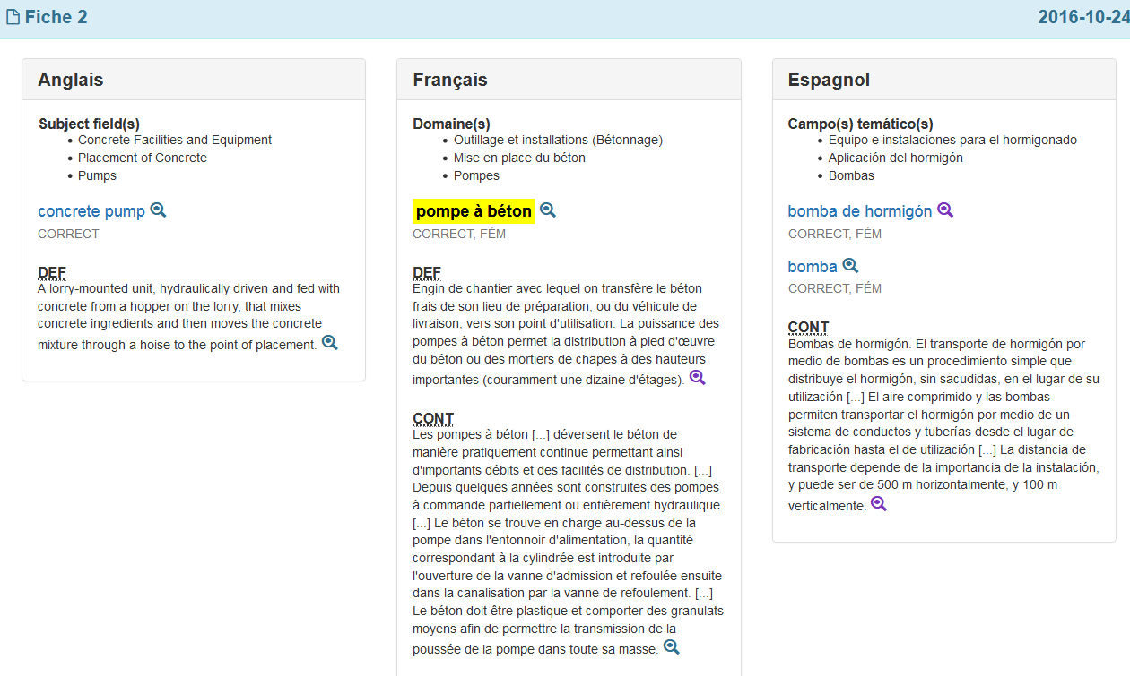

WIKIPEDIA_INGELESEZ

A concrete pump is a machine used for transferring liquid concrete by pumping. There are two types of concrete pumps.
The first type of concrete pump is attached to a truck or longer units are on semi-trailers. It is known as a boom concrete pump because it uses a remote-controlled articulating robotic arm (called a boom) to place concrete accurately. Boom pumps are used on most of the larger construction projects as they are capable of pumping at very high volumes and because of the labour saving nature of the placing boom. They are a revolutionary alternative to line-concrete pumps.
The second main type of concrete pump is either mounted on a truck or placed on a trailer, and it is commonly referred to as a line pump or trailer-mounted concrete pump. This pump requires steel or flexible concrete placing hoses to be manually attached to the outlet of the machine. Those hoses are linked together and lead to wherever the concrete needs to be placed. Line pumps normally pump concrete at lower volumes than boom pumps and are used for smaller volume concrete placing applications such as swimming pools, sidewalks, and single family home concrete slabs and most ground slabs.
There are also skid mounted and rail mounted concrete pumps, but these are uncommon and only used on specialized jobsites such as mines and tunnels

HOW DOES A CONCRETE PUMP TRUCK WORK?
https://www.everything-about-concrete.com/how-does-a-concrete-pump-truck-work.html

If you've ever wondered, "How does a concrete pump truck work?" I'll explain how a concrete pump works and also why to use a concrete pump truck.

We use concrete pump trucks quite frequently to place the concrete for basement floors, large concrete slabs, pool decks and just about anything else we can't reach using the concrete trucks chutes and a 16 foot cold chute.
WHY USE A CONCRETE PUMP TRUCK?
Some advantages for using a pump truck to place your concrete are; the pump truck can reach over houses and into backyards, a pump truck can pump concrete up 2, 3, 4 floors and more, pump trucks place the concrete right where you need it, pumping concrete is fast which saves on labor cost, pumping the concrete reduces the amount of manpower you need to place the concrete.
If you've ever wheelbarrowed 10 - 20 yards of concrete over a long distance or used a concrete powerbuggy to place a 100 yard slab, you know exactly what I mean. You know why it makes sense to use a concrete pump truck.

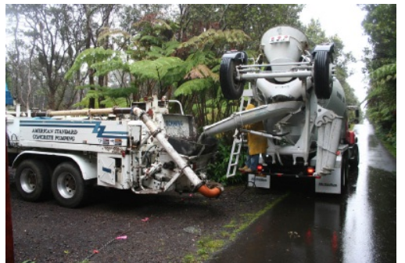

HOW DO CONCRETE PUMP TRUCKS WORK?
The simple answer to "how concrete pumps work" is, a concrete truck discharges its concrete into a hopper on the back of the pump truck. The hopper has a mesh grate the concrete falls through which prevents any large rocks or chunks from plugging the pump truck hoses. The hopper also has an auger that churns the concrete keeping it liquid and flowable.
Once the concrete is in the hopper, it gets sucked into a valve system in small intervals or strokes. As some of the concrete is being sucked into the valve, the concrete before it is being simultaneously pushed through the concrete pipe on the pump truck boom until it reaches the end of the concrete hose and placed where you need it.
Some concrete pump trucks have different types of valve systems, s-valves, ball-valves, but basically that's how a concrete pump works. As long as the hopper stays full and there are no blockages in the concrete hoses, the process of pumping the concrete goes quite smoothly.
Having a good concrete pump truck operator is also very important. Their experience and wisdom is key to handling any problems that may occur, fixing them, and keeping the pour going.

CONCRETE BOOM PUMP TRUCKS

https://www.everything-about-concrete.com/concrete-boom-pump.html

Concrete boom pump trucks are used for concrete pumping projects ranging from residential swimming pools, floors and foundations to large scale commercial concrete floors and walls. The time and labor saved by using a boom pump to place the concrete on these hard to reach projects make using them an easy choice.
A concrete pump truck can range in size from single axle, suitable for confined areas where maneuvering is limited, to ten axle pump trucks used for large scale projects where long reach is needed.  Convenience, time savings, and ease of pour are just a few words that describe using a pump truck with a long boom that can reach 100 feet or more. | 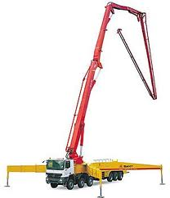

The two kinds of booms on concrete pump trucks:
1. Roll-and-fold boom pumps provide control and convenience on site. The versatility of their four-section booms combined with highly flexible boom tip articulation helps complete jobs faster and more efficiently.

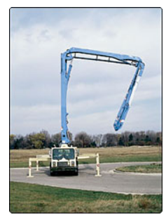

2. Z-Booms are perfect for all boom pump applications, Z-Booms are especially suited for jobs where height restrictions are a concern. On crowded job sites and under low ceiling heights, Z-booms help you place concrete with ease.

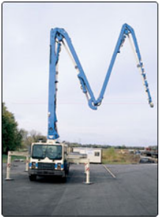

Putzmeister concrete pump trucks have roll-and-fold booms that range in size from 42 meter (124 feet horizontal reach) to 61 meter (184 feet horizontal reach) and Z-Booms that range in size from 20 meter (54 feet horizontal reach) to 70 meter (212 feet horizontal reach).
The largest truck-mounted boom pump on the market, the 70Z-Meter offers over 227 feet of vertical reach and nearly 213 feet of horizontal reach. This model features Putzmeister's exclusive Ergonic technology and a five-section Z-Fold boom design that allows maximum flexibility.

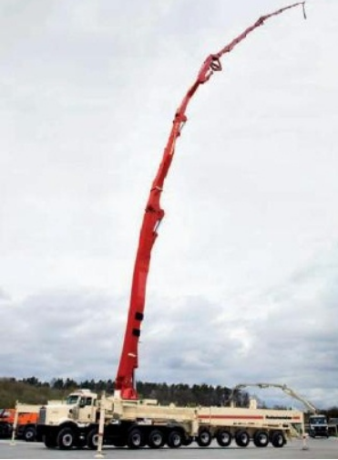

A boom pump usually stays in one place for the entire pour thanks to the long reach of the boom. This makes for fast, efficient concrete placements where, on most job-sites, the concrete is poured from one hose attached to the end of the boom, also called "dangle pumping".
If you need a concrete boom pump truck for a concrete placement, there are many concrete pumping contractors you can hire to pump the concrete for you. Check with your local concrete supply store for business cards or search online. Most concrete pump operators charge a flat fee for the first 4 hours, then charge by the hour after 4 hours

WIKIPEDIA_FRANTSESEZ

Une pompe à béton est un matériel servant à transporter le béton dans un tuyau souple ou rigide, pour l'acheminer en hauteur ou au-delà d'un obstacle lorsque le camion malaxeur ne peut accéder directement au lieu de coulage ou de projection.
Pompe à béton statique
Ces pompes, de diverses tailles et débits, comprennent un bac déverseur dans lequel on déverse du mortier. Une pompe est située sous le bac, elle prend du béton dans un cylindre et le pousse dans un tuyau par un piston hydraulique.
Pompe à béton sur camion
Ces pompes sont couramment intégrées à des camions, alors dits eux aussi « pompes à béton ». Ces engins sont équipés d'un bras hydraulique qui se déplie et qui peut se diriger dans plusieurs directions. Sur ce bras est fixé le tuyau métallique dans lequel passe le béton ; c'est le chauffeur qui contrôle le bras à l'aide d'une télécommande. Un tuyau souple en caoutchouc permet d'ajuster simplement en le poussant le point de déversement du béton.
Il existe des camions malaxeurs équipés de leur propre pompe et bras hydraulique. À cause du poids de l'ensemble, la contenance de la cuve s'en trouve amoindrie, souvent autour de 5 m3.

Le camion pompe
Le camion pompe est un véhicule exclusivement dédié à la manutention du béton. Grâce à sa flèche, il assure l’acheminement du matériau de la sortie du camion toupie jusqu’au lieu de coulage

Le camion pompe à béton
https://travauxbeton.fr/camion-pompe/

Le camion pompe, également appelé « pompe à béton » est un véhicule de manutention, qui permet d’acheminer le béton dans des endroits difficiles d’accès ou éloignés.

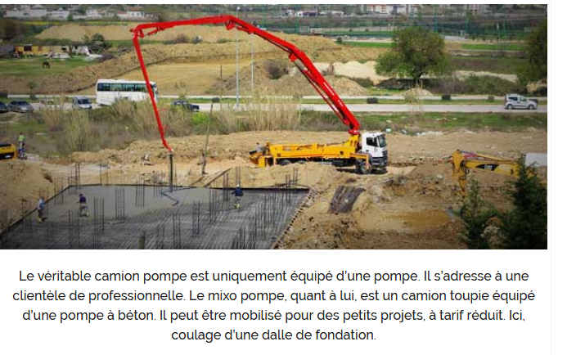
Pour mener à bien cette mission, le camion pompe est équipé d’un dispositif composé d’un bras combiné à un flexible de distribution.

Le mixo pompe
A l’inverse du mixo pompe, qui est un camion toupie avec pompe, la pompe à béton est exclusivement dédiée au pompage du béton

